**pickup_dt:** Time period of the observations.

**borough:** NYC's borough.

Bronx

Brooklyn

EWR

Manhattan

Queens

Staten Island

NA

**pickups:** Number of pickups for the period.

**spd:** Wind speed in miles/hour.

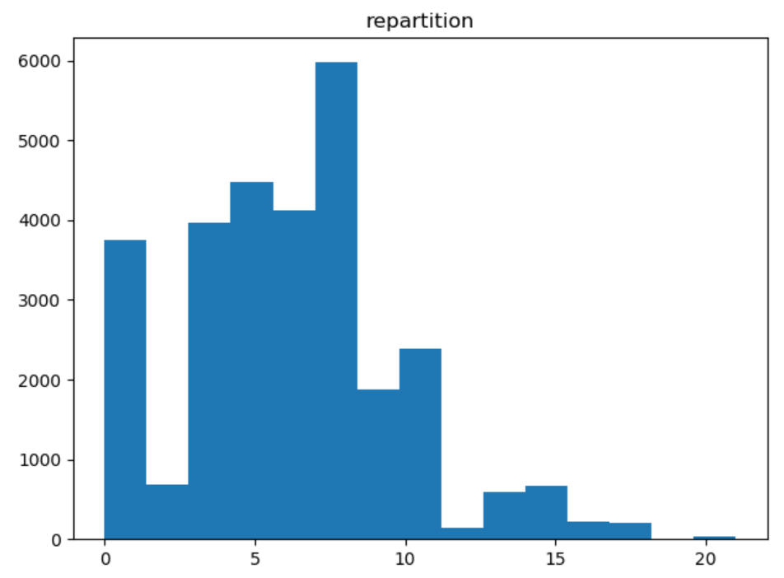

**vsb:** Visibility in Miles to nearest tenth.

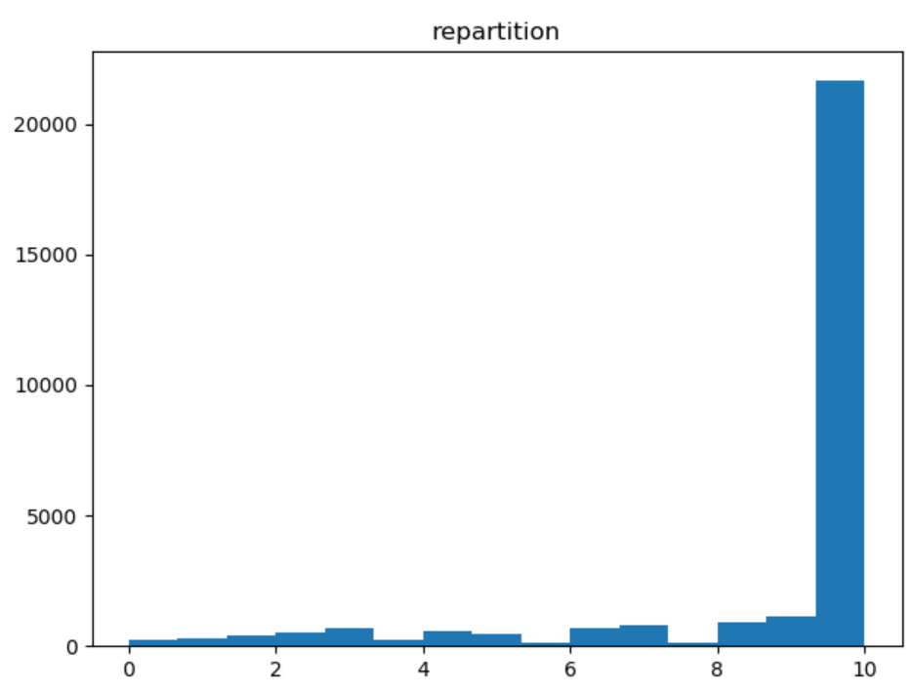

**temp:** temperature in Fahrenheit.

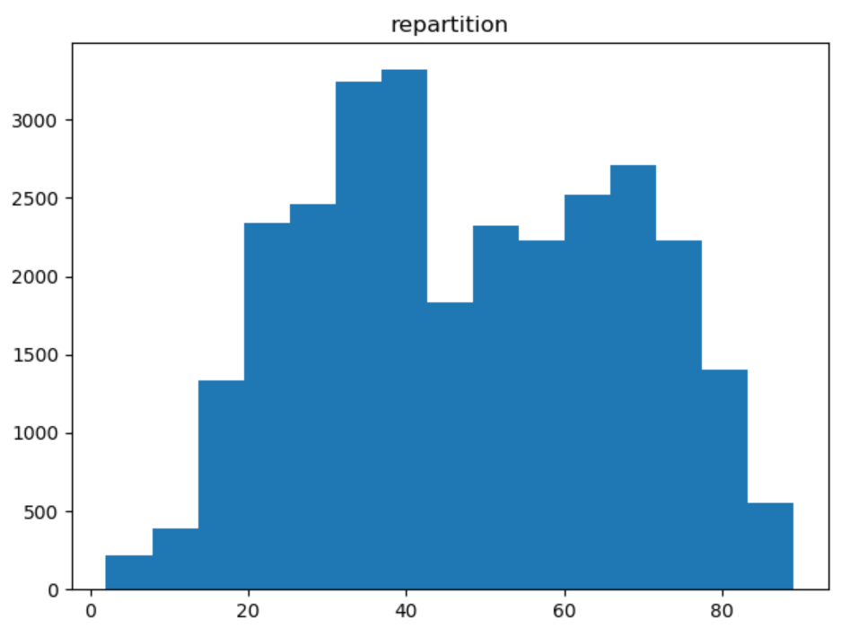

**dewp**: Dew point in Fahrenheit.

“If the air temperature cools to the dew point, or if the dew point rises to equal the air temperature, then dew, fog or clouds begin to form. At this point where the dew point temperature equals the air temperature, the relative humidity is 100%.

If there is then further cooling of the air, say because the air parcel is rising to higher (and thus colder) levels in the atmosphere, even more water vapor must condense out as additional dew, fog, or cloud, so that the dew point temperature then falls along with the air temperature. This is how precipitation forms...when water vapor is removed from the air so rapidly that the liquid water drops grow to a size where they fall out of the cloud.”

* See in relation with temperature

**slp:** Sea level pressure.

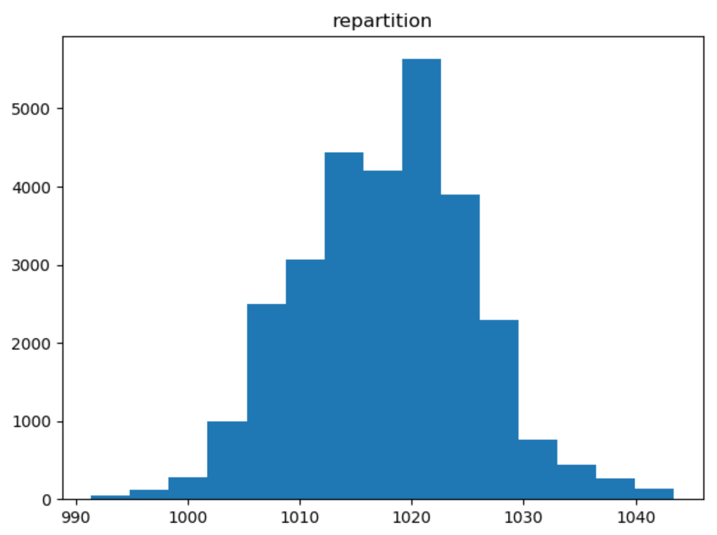

**pcp01:** 1-hour liquid precipitation.

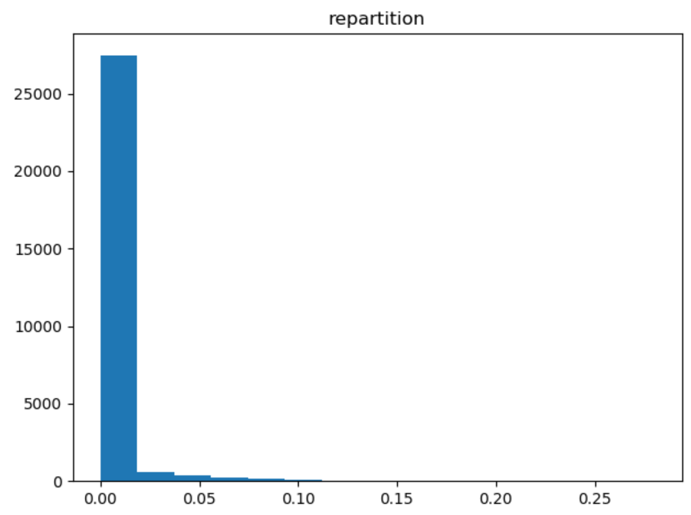

p**cp06:** 6-hour liquid precipitation.

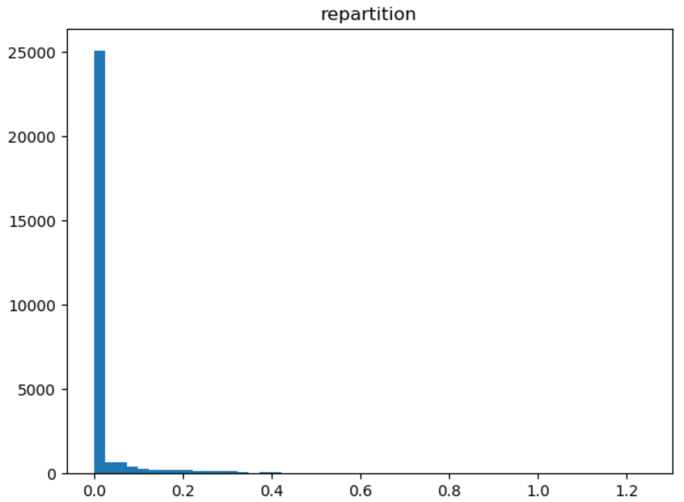

**pcp24:** 24-hour liquid precipitation.

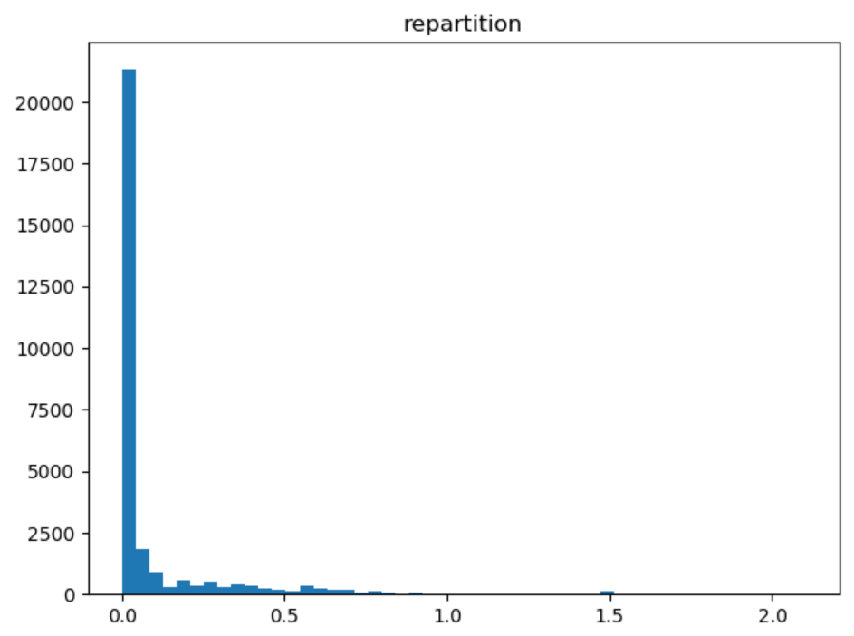

**sd:** Snow depth in inches.

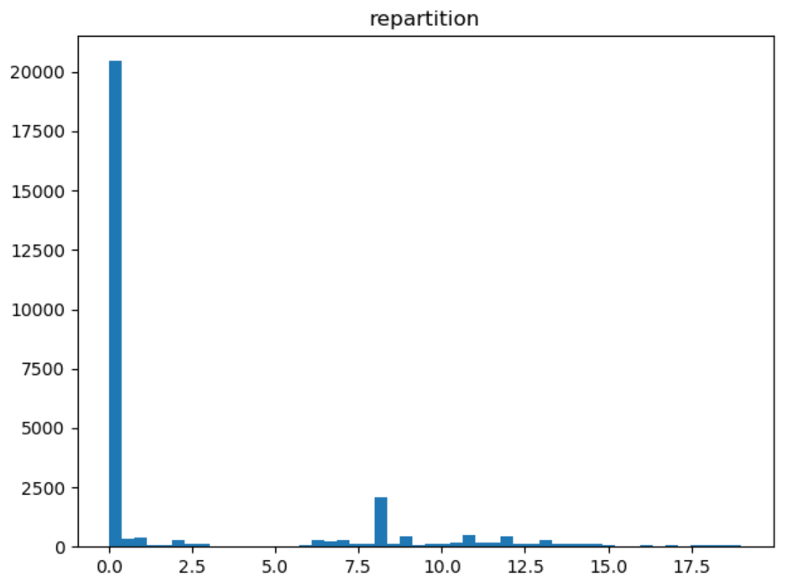

**hday:** Being a holiday (Y) or not (N).

